FILTERS
- Display the median daily rate of employees belonging to HR department and who have left the organization with job level as 2.
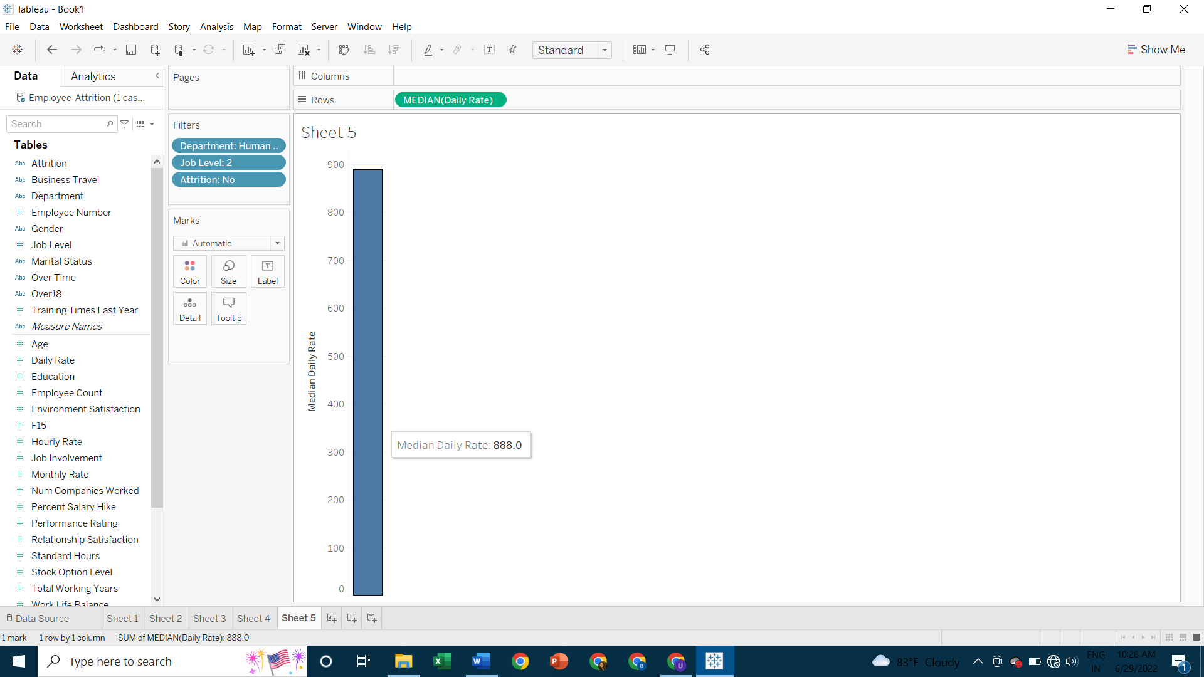

- Display the total monthly rate of single and married employees belonging to sales and HR department with gender containing the letter “f”.
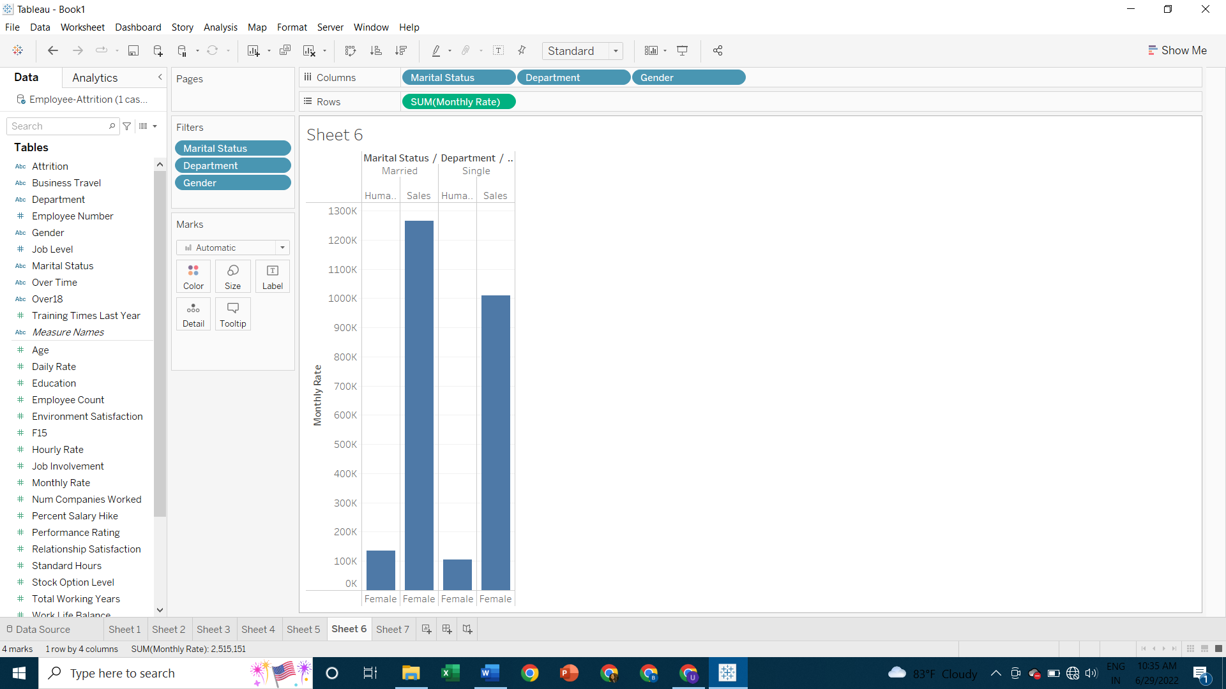
- Display the different departments where median hourly rate of employees >60
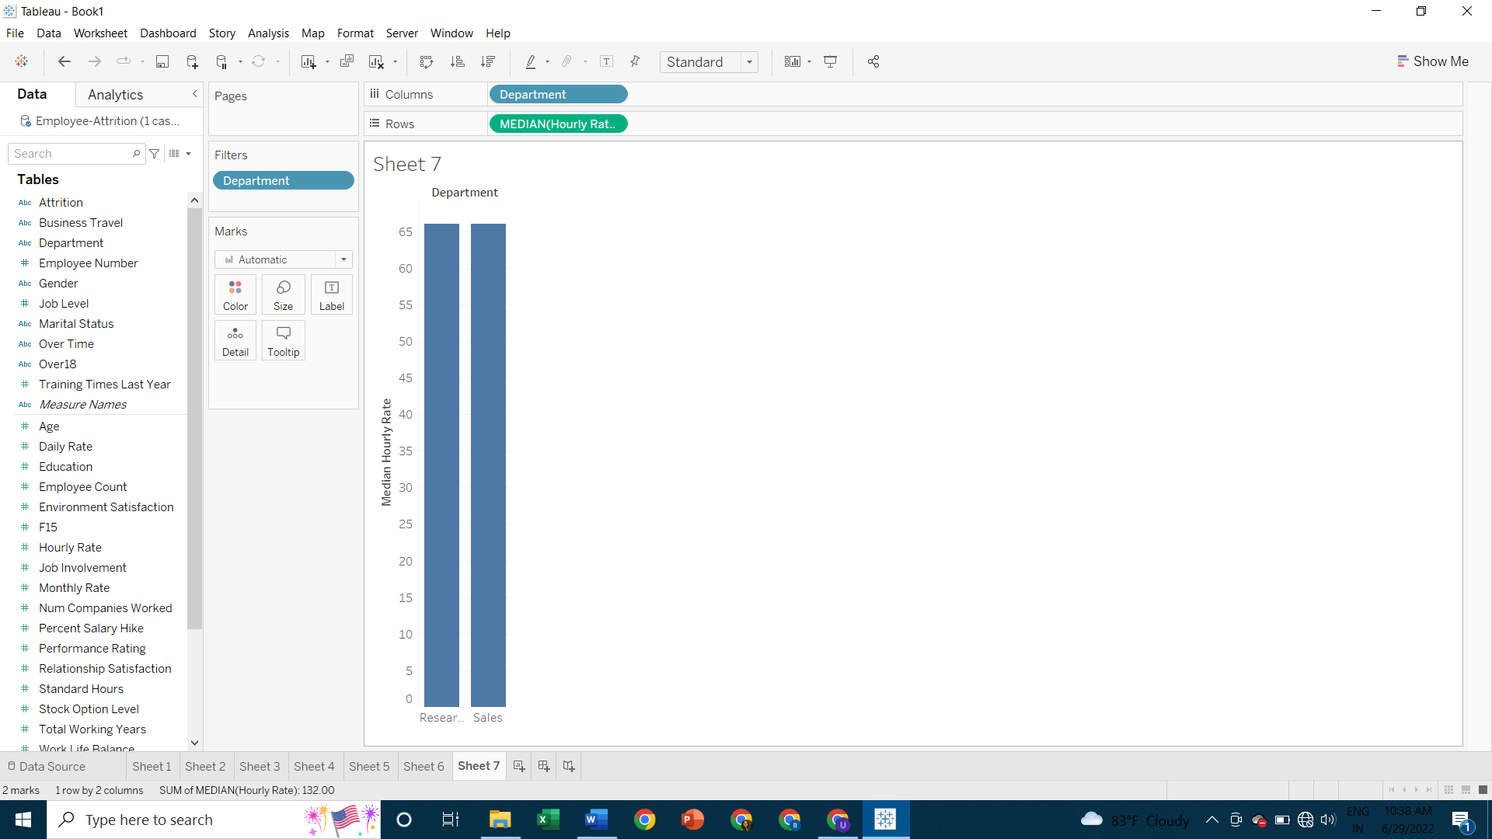
- Display the marital status of employees having average daily rate greater than 700 and belonging to the sales department having job involvement as 2 and environment satisfaction as 3.
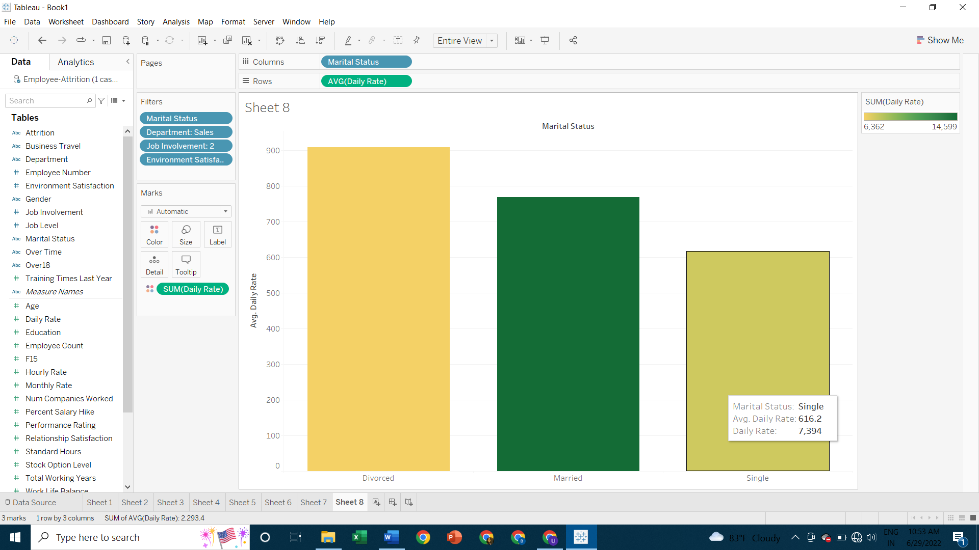
- Display the marital status of employees belonging to the sales department having job involvement as 2 and environment satisfaction as 3 having average daily rate greater > 700.
